

MAKERERE UNIVERSITY

COLLEGE OF COMPUTING AND INFORMATION SCIENCE

SCHOOL OF COMPUTING AND INFORMATICS TECHNOLOGY BACHELOR OF SOFTWARE ENGINEERING

SOFTWARE REQUIREMENTS SPECIFICATION DOCUMENT FOR THE

MATERNAL MORTALITY RATE PREDICTION AND ADVISORY SYSTEM

COURSE CODE: BSE 4100

COURSE NAME: SOFTWARE ENGINEERING PROJECT 1

SUPERVISOR: DR. MOSES NTANDA

GROUP MEMBERS (GROUP BSE 21-11)

# | Names | Registration Number | Signature
1 | WAMALA EDGAR WATSON | 17/U/20633/EVE
2 | KYANZI HASSAN MUSISI | 17/U/19979/EVE
3 | ASIIMWE BRENDA ANGEL | 17/U/3014/EVE
 | TINDYEBWAFORTUNATE
4 | ALLAN | 17/U/10441/EVE

Software Requirements Specification For

MATERNAL MORTALITY RATE PREDICTION AND ADVISORY SYSTEM

Version 1.3 approved

Prepared by: BSE21-11

20/01/2022

Table Of Contents
1.0 Introduction 7
1.1 Purpose 7
1.1.1 Scope 7
1.1.2 Definitions, acronyms and abbreviations. 8
1.2 Document Conventions 9
1.3 Intended Audience and Reading Suggestions. 9
1.4 Product Scope 15
1.5 References. 15
2.OVERALL DESCRIPTION 16
2.1 Product Perspective 16
2.1.1 What the Product shall do. 17
2.1.2 User Activities 17
2.2 User Classes and Characteristics 18
2.3 Operating Environment 19
2.4 Design and Implementation Constraints 19
2.5 User Documentation 20
3.0 EXTERNAL INTERFACE REQUIREMENTS 21
3.1 User Interfaces 21
3.2 Hardware Interfaces. 24
3.3 Software Interfaces 25
3.4 Communications Interfaces. 25
4. SYSTEM FEATURES 26
4.1 Functional Requirements 26
4.1.1 User class 1- The User 26
5.0 29
OTHER NONFUNCTIONAL REQUIREMENTS 29
5.1 Performance Requirements 29
5.2 Safety Requirements 30
5.3 Security Requirements 30
5.4 Software Quality Attributes. 30
5.4.1 Reliability 30
5.4.5 Portability 34
5.5 Design Constraints 35

List of Figures
Figure 1:Maternal Mortality Prediction and Advisory System Perspective 16
Figure 2:Product perspective 16
Figure 3:Admin Interface 21
Figure 4:Register Pregnant mother’s interface 22
Figure 5:Doctor-solution interface 23
Figure 6: Doctor advice page 24

List of Tables
Table 2: Acronyms and abbreviations 9

Revision History

Name | Date | Reason for Changes | Version
Tindyebwa Fortunate Allan | 01/04/2021 | First draft of the document | 1.0
Wamala Edgar Watson | 20/04/2021 | Changes in the overall description | 1.1
Brenda Asiimwe Angel | 01/10/2021 | Changes in System features | 1.2
Kyanzi Hassan Musisi | 20/01/2022 | Changes in functional and non-functional requirements. Document sign off | 1.3

1.0 Introduction

1.1 Purpose

This document specifies the Software Requirements Specification (SRS) for the MATERNAL MORTALITY RATE PREDICTION AND ADVISORY SYSTEM of version 1.3. It does explain the purpose and features of the system, the interfaces of the system, what the system will do, the constraints under which it must be designed, implemented and operate and how the system shall react when users interact with it.

The document is intended for both the stakeholders and the developers of the system and it was proposed to Dr. Moses Ntanda for its approval so it was as a reference for developing the first version of the system by the BSE21-11 team.

1.1.1 Scope

The “MATERNAL MORTALITY RATE PREDICTION AND ADVISORY SYSTEM” is a mobile-based and web application which provides replies to mother seeking answers to their issues regarding maternal health, it also advises the general public about maternal health about maternal health care. The system sends replies to users through sms messaging via an ‘sms’ messaging system. This system also also does prediction, analysis and simulation for all parties interested in maternal health and maternal health being an indicator of the how Uganda is doing health wise and financial wise, the prediction and analytics system is important to policy makers to determine how much they need to spend on maternal health care based on what is expected to happen in the future. Both the web and phone applications should be free to use.

The system administrators can add women telephone numbers to the system to send them regular reminders to attend to antenatal care. We shall obtain details of current mothers from information gathered at different health centers for the start as we find other means to capture data about those mothers that neither visit the hospital or only go there when it’s their due time to give birth. The system will pick the already existing information from the database which include phone numbers of mothers on which messages will be sent. An administrator also uses the web-portal in order to manage the system and keep the information accurate. The doctors being the sole providers of maternal health care information, they will be able to provide answers to pressing issues women are facing. The administrator can, for instance verify user details, approve system officials on web-portal and manage user information.

Furthermore, the women require airtime to send their issues to our number to get a reply, other users require both Internet to send requests to database and receive response from database through webserver. All system information is maintained in a database, which is accessed through a web-server. The web portal will be mainly used by the system administrator, and it has the capability of analytically representing both summary and detailed information about the results for the maternal mortality analytics, through the web portal too the administrators will verify users, track user results, register other administrators, among others as further explained in the system architecture.

1.1.2 Definitions, acronyms and abbreviations.

Term |  | Definition
User |  | Someone who interacts with both the web and | mobile phone application
MMRPAS |  | Maternal Mortality Rate Prediction and Advisory System
MMR |  | Maternal Mortality Rate
Admin/Administrator |  | System administrator who is given specific permission for managing and
 |  | controlling the system
Web-Portal |  | A web application which presents special features for the admins
Application Store | An installed application on mobile phone which helps user to find new
 | compatible applications with mobile phone platform and download them
 | from Internet
Stakeholder | Any person who has interaction with the system who is not a developer.
DHIS2 | District Health Information Software 2
W.H. O | World Health Organization
DEP | Dependency
TAG | A unique, persistent identifier contained in a |  | Programming Language
TAG | statement [2]

GIST | A short, simple description of the concept contained in a Programming
 | Language statement [2]
SCALE | The scale of measure used by the requirement contained in a Programming
 | Language statement [2]
DEFINED | The official definition of a term contained in a Programming Language
DEFINED | statement [2]

Table 1: Acronyms and abbreviations

1.2 Document Conventions

Conventions used throughout this SRS document include;

- Font Type: Times New Roman.

- Size: 16 for Headings and 14 subheadings.

- Size: 12 for the rest of the document.

1.3 Intended Audience and Reading Suggestions.

This document is to read by the development team that requires obtaining a clear picture of the system they are to develop, Project Manager that needs to monitor the progress and coordinate the system development process, Project Testers that test the system whether the implementation meets the specifications and Project Stakeholders that include; doctors, mid wives, and administrators, developers together with End Users to understand the requirements.

Reader 1: Project Manager.

A project Manager is expected to read all the sections in this document that include;

- 1.0: Introduction.

- 2.0: Overall Description.

- 3.0: External Interface Requirements.

- 4.0: System Features.

- 5.0: Other Nonfunctionally Requirements.

- 7.0: Appendix A: Glossary.

- Appendix B: Analysis Models.

Reader 2: Development Team.
The development Team for the MMRPAS comprises (4) members of the group named Kyanzi Hassan Musisi, Tindyebwa Fortunate Allan, Asiimwe Brenda and Wamala Edgar Watson.

BSE21-11.

The most prominent sections of this document that must be read by the Development Team include;
- 2.1: Product Perspective.

- 2.2: Product Functions.

- 2.3: User Classes and Characteristics.

- 2.4: Operating Environment.

- 2.5: Design and Implementation constraints.

- 2.7: Assumptions and Dependencies.

- 3.0: External Interface Requirements

- 4.0: System Features.

- 5.0: Non-Functional Requirements.

However, some of the sections of this SRS document that may be skipped by the Development Team include;
- 1.1: Purpose.

- 1.2: Document Conventions.

- 1.3: Intended Audience and Reading Suggestions.

- 1.4: Product Scope.

- 1.5: References

- 2.6: User Documentation.

Reader 3: End User.
End users of the finished system include; pregnant women and health officials and the general public. That is to say those who put the application to use. These end users shall obtain different information basing on user

type. The most prominent sections of this SRS document that must be read by the End User Majorly the Health officials include;

- 2.2: Product Functions.

- 2.3: User Classes and Characteristics.

- 2.4: Operating Environment.

- 2.6: User Documentation.

- 3.1: User Interfaces.

However, some of the sections of this SRS document that may be skipped by the End User while reading through this document include;

- 1.0: Introduction.

- 2.1: Product Perspective.

- 2.5: Design and Implementation Constraints.

- 2.7: Assumptions and Dependencies.

- 3.2: Hardware Interfaces.

- 3.3: Software interfaces.

- 3.4: Communication Interfaces.

- 4.0: System Features.

- 5.0: Other Non-Functional Requirements.

Reader 3: Project Testers.
Project testers can use this SRS document as a base for their testing strategy as some faults and failure instances are easier to find using a requirements document. This way, testing becomes more methodically organized.
The most prominent sections of this SRS document that must be read by the Project Testers include;

- 2.5: Design and Implementation Constraints

- 2.7: Assumptions and Dependencies

- 4.0: System Features

- 5.0: Other Non-functional Requirements

However, some of the sections of this SRS document that may be skipped by the Project Tester while reading through this document include;

- 1.2: Document Conventions.

- 1.3: Intended Audience and Reading Suggestions.

- 1.5: References.

- 2.6: User Documentation.

Reader 4: Project Stakeholder.

The project stakeholders for the MMPAS comprise women, doctors, policy makers and the general public including husbands of pregnant women. The most prominent sections of this SRS document that must be read by the End User include;2.2: Product Functions.2.3: User Classes and Characteristics.

- 2.4: Operating Environment.

- 2.6: User Documentation.

- 3.1: User Interfaces.

However, some of the sections of this SRS document that may be skipped by the End User while reading through this document include;

- 1.0: Introduction.

- 2.1: Product Perspective.

- 2.5: Design and Implementation Constraints.

- 2.7: Assumptions and Dependencies.

- 3.2: Hardware Interfaces.

- 3.3: Software interfaces.

- 3.4: Communication Interfaces.

- 4.0: System Features.

- 5.0: Other Non-Functional Requirements.

1.4 Product Scope
The Maternal Mortality Rate Prediction and Advisory System is both a mobile and web application system intended to provide advice to women by providing them replies to the issues affecting them that they would rather have taken a long time, a lot of money to access maternal health care fully trained officials who are few, expensive and very hard place meetings with. So, our system comes in as an intervention to reducing preventable maternal mortalities by providing maternal health care related information easily to women. Our system can also provide analytics of maternal mortality rates of different region in Uganda. The system also provides real-time prediction to different stake holders. The predictions enable concerned parties to plan accordingly for population more so in regions that are affected more by this maternal mortality problem.

The system is proposed for use in only Uganda as a country, owned and managed by the Group BSE 21-11.

1.5 References.

[1] IEEE Software Engineering Standards Committee, “IEEE Std 830-1998, IEEE Recommended Practice for Software Requirements Specifications”, October 20, 1998.

- Karlsson J, “A Cost-Value Approach for Prioritizing Requirements”, Norges Teknisk

- Davis M A, “Just Enough Requirements Management: Where Software Development Meets Marketing”, New York, Dorset House Publishing, 2005.

2.OVERALL DESCRIPTION
2.1 Product Perspective
This Maternal Mortality Prediction and Advisory System consist of three parts: prediction system, a web portal, and an SMS messaging system.

The sms messaging system comes to a mobile phone through GSM technology, which aids the sending of messages to the pregnant women phones.

This is a data-based application, it will require a data store, and thus a database will be needed. The web portal will communicate with the database via a web server, however in slightly different ways. The web portal will mainly be used by users to add and modify data.

The problems with overloading the operating system the application is only allowed to use 20 megabytes of memory while running the application. The maximum amount of hard drive space is also 20 megabytes.

The application is purposely proposed to solve the problem of persistent maternal mortality through providing reliable advice or information regarding maternal health care to women while they are pregnant or before they get pregnant. An intervention to maternal mortality would be providing women with maternal health care information as we sighted this as one of the causes of maternal deaths, the system is also supposed to provide real-time and reliable predictions and analytics to stakeholders.
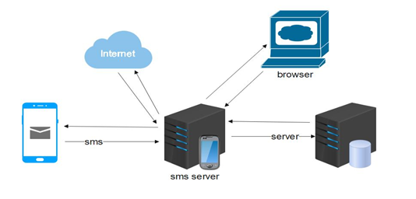
Figure 1:Maternal Mortality Prediction and Advisory System Perspective
Figure 2:Product perspective

2.1.1 What the Product shall do.

The Maternal Mortality Prediction and Advisory System shall;

- Provide real-time and reliable analytics and predictions to users.

- Deliver sms messages in real time to women as replies to their questions.

- Provide a platform for users to connect to nearby maternal health centres in their regions or districts in Uganda.

- Provide a platform for health officials to share advice to pregnant women

The web-portal which will be used by the admin and system officials shall:

- Allow administrators login with admin account.

- Allow system administrators manage maternal mortality data.

- Enable administrators manage user credentials

2.1.2 User Activities

The activities to be performed by users while using the product include;

- Login Every user on first use of the system, shall be able to sign in with either email/google or Facebook, on which after application will ask for phone details stored for application purposes.

- Upload dataset: A user can upload a database and carry out analysis and prediction activities

- Send question inform of messages: They can send an SMS message to our system number in Realtime

- Share Information: The doctors shall be able to share relevant information as replies to pressing issues of women .

2.2 User Classes and Characteristics

There are basically two classes of users that shall interact with the system and these include. End Users of the web based and Administrators. Each of these two classes of users has different use of the system so each of them has their own characteristics.

End Users:

for advisory information. This implies that End Users should have characteristics that include.

- Should be Computer literate with knowledge in internet access and computer usage.

- Should be motivated by the availability of accurate product details.

- Should have knowledge about how to navigate through web-based system interfaces to get a relevant result. This is because they must specify an appropriate search

The Administrators:
The Administrators only interact with the web portal. They manage the overall system so that there is no incorrect information within it. The administrator can manage the information for product information, database management as well as the options for both the External users and the system owners.

Administrators should have characteristics that include.

- Should have skills with knowledge of programming languages include HTML, CSS, MYSQL, python, JavaScript, PHP as used in the implementation of the system to be in position to understand the system fully.

- Should be able to track system logs on real time.

- Should have skills in handling urgent issues that may arise in the system to avoid system shut down.

2.3 Operating Environment
The MMRPAS is platform independent and it shall run on every platform. It shall be tested on Microsoft Windows and GNU/Linux distribution.

The system will be supported by all browsers such as Mozilla Firefox, Google chrome and many more.

2.4 Design and Implementation Constraints
- The application shall be built using JavaScript, php and python programming language.

- Python shall be used as the server-side scripting language.

- SQLite server shall be used to run the back-end web application.

- The database for the web application shall be implemented using MYSQL

- The web application shall be built using a standard web page development tool that conforms to either IBM’s CUA standards or Microsoft’s GUI standards using HTML, CSS, and JavaScript.

- The computer must be equipped with web browsers such as internet Explorer, Mozilla and Google Chrome.

- The product shall be accessed and used only in the presence of an internet connection. This is because the system shall require fetching data from the database over the Internet and therefore it is crucial that there is an Internet connection for the system to function properly.

- Maintenance of the finished and deployed system shall be done by only the development team involved in its development.

- The system use shall be limited to only English language understanding users.

- This web-based system will be viewed on only a few multimedia devices such as phones, tablets, laptops and monitors.

2.5 User Documentation
The user manual for the MMRPAS shall be available to administrative users through a given link that shall be provided.

2.6 Assumptions and Dependencies

- System Access: The finished product is assumed to be web based that is to say; accessed and used over internet and supported by all browsers such as Mozilla, Google Chrome, and Internet Explorer. In addition to this, a mobile application will be availed to access the system for smartphone users.

- Performance: Another assumption about the product is that it will always be used on devices that have enough performance. If a device does not have enough hardware resources available for the product, for example users might have allocated resources with other applications thereby creating a scenario where the product does not work as intended or even at all.

- User capability: It is assumed that users of the finished product shall be well acquainted with the English language

  - System Monitoring: A finished, and deployed system shall require a System(s) Administrator that shall continuously monitor its performance to ensure that it is up and operating in real time.

3.0 EXTERNAL INTERFACE REQUIREMENTS

3.1 User Interfaces

The user interface of the MMRPAS must be interactive to the user and give ease of use by making the features of the application visible to the user, implementing the required standards.

The System owners and Administrators shall interact with the system through a web-portal where the System owner should be able to register with Username and password on the web-portal to log in and manage the system information and an administrator also can be able to log in to the web-portal with a username and password where he/she can administer the system by for instance editing system or user information.

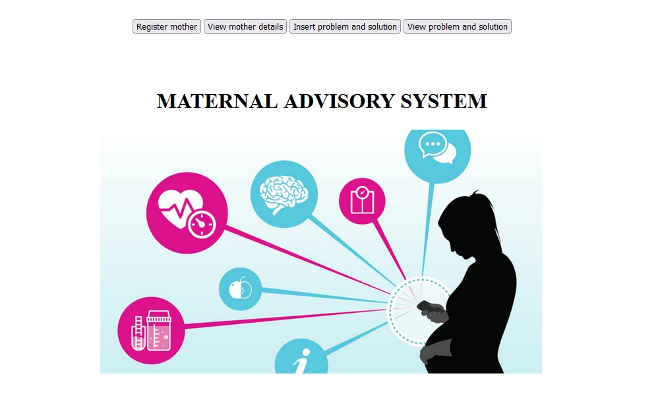
Figure 3:Admin Interface

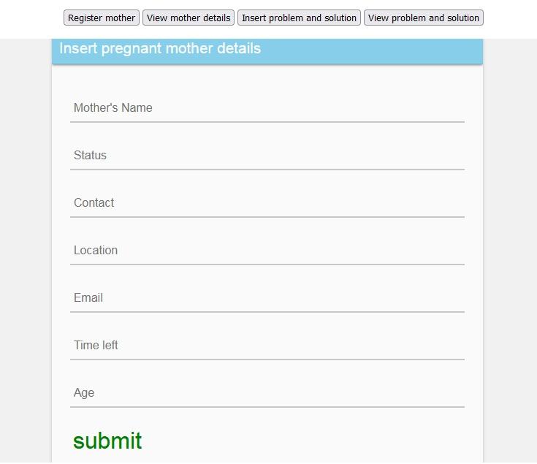

Figure 4:Register Pregnant mother’s interface

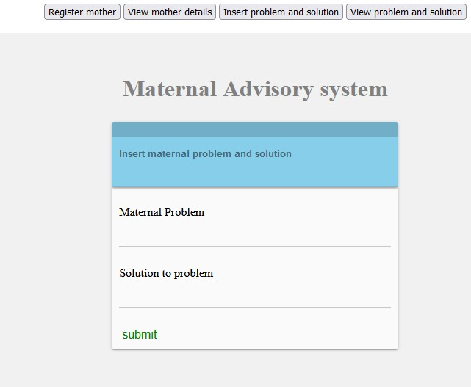
Figure 5:Doctor-solution interface

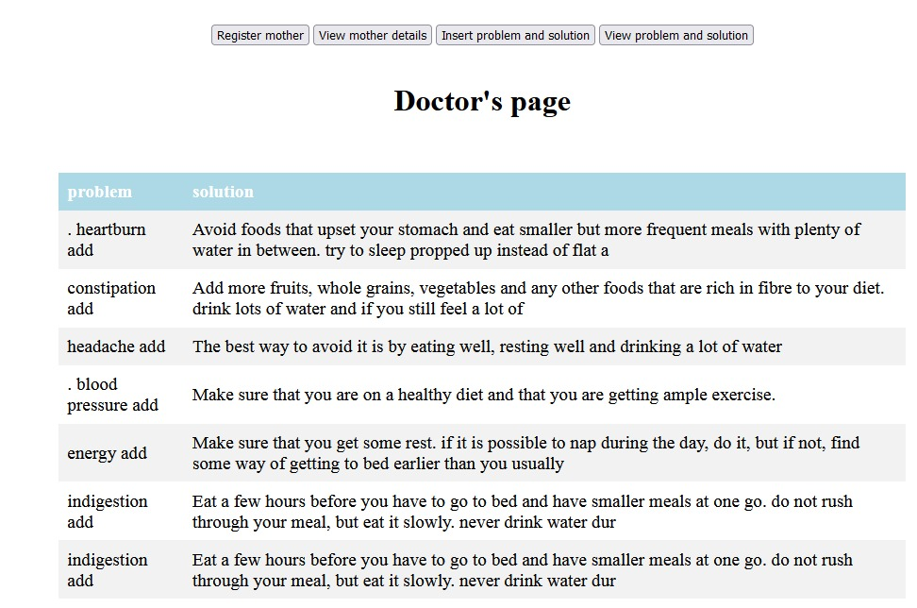
Figure 6: Doctor advice page

3.2 Hardware Interfaces.

Since the system must run over the internet, all the hardware shall require internet connection with hardware interface for the system. As for example. Modem, WAN – LAN, Ethernet Cross-Cable.

The GSM device requires a sim card with airtime in order to enable message sending and receiving.

3.3 Software Interfaces
The communication between the database, client application side and the web-portal consist of operation concerning reading and modifying data, while the communication between the application and database will be through reading only.

3.4 Communications Interfaces.

The system uses a communication protocol to transmit messages among application part, web-portal and database part. HTTP, SMTP, FTP protocol will mainly be used for communication among the web-portal, database, and E-mails. WAP protocol shall be used between host subsystems and transport level protocol will be TCP/IP.

The system shall depend on SMS bulk to send phone number verification messages to users.

The system shall provide Web service interface for accessing its main functionality from an external system.

4. SYSTEM FEATURES

In this section, we organize the functional requirements for the product by system features, the major services provided by the product.
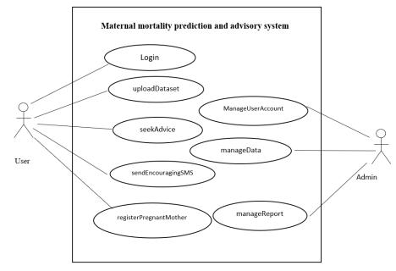

Figure: Use case diagram for the MMRPAS

4.1 Functional Requirements

4.1.1 User class 1- The User

ID: FR01

TITLE: Login
DESC: Given that the user has opened the application, the system shall allow him to enter valid username and password to be able to use and access the system.

RAT: For the user to access the system through logging with valid inputs

DEP: None

ID: FR02

TITLE: Upload Dataset

DESC: Provided the user has logged in into the system. The system shall allow the user to upload the desired dataset and make the necessary analysis and prediction and then come up with the necessary advice basing on the output result.

RAT: To be to upload the required dataset for analysis

DEP: Login

ID: FR03

TITILE: Seek advice

DESC: After making the necessary analysis and prediction, the system shall allow the user to seek advice from the system by clicking on the seek advice button.

RAT: To seek advice from the system

DEP: Login, Upload Dataset

ID: FR04

TITLE: Send Encouraging SMS

DESC: The system shall allow users to automatically send encouraging messages to pregnant mothers or women.

RAT: To send encouraging SMS messages to pregnant mothers

DEP: Login, Seek Advice

ID:FR05

TITLE: Register Pregnant Mother

DESC: The system shall allow users to register details of pregnant mothers like email, phone number location and full name.

RAT: To register details of a pregnant mother into the system

DEP: login, Upload Dataset.

ID:FR06

TITLE: Analyse Predict Model

DESC: The system shall allow users to make analysis and predictions based on the dataset uploaded.

Hence through visualization.

RAT: To make analysis and predictions through visualization.

DEP: Upload Dataset, login

5.0

OTHER NONFUNCTIONAL REQUIREMENTS

5.1 Performance Requirements
The requirements in this section provide a detailed specification of the user interaction with the software and measurements placed on the system performance.

ID: QR01

TITLE: upload/take picture feature

DESC: This feature should be prominent and easy to find for the user.

RAT: In order to for a user to find this feature easily.

DEP: none

ID: QR02

TAG: System Dependability

GIST: The fault tolerance of the system.

SCALE: If the system loses the connection to the Internet or to the GPS device or the system fails to report fake product or any notification, the user should be informed. METER: Measurements obtained from 1000 hours of usage during testing.

MUST: 100% of the time.

5.2 Safety Requirements
The system must ensure that it leaves untouched the input data. No modification of System information is allowed by End user except by the Administrator.

Moreover, the system should function even in cases of wrong data insertion or wrong settings.

The system should provide users with appropriate help messages in case of any error(s).

5.3 Security Requirements
The system audits some Activities performed by user with the audit entries being tamperproof or at least tamper evident and stored in a secured storage.

All audit entries must at least contain the following: Time stamp when the user performed an action, Action description of activities that are audited, Global events such as logon, logoff, password changes performed specifically by the System’s administrator, Creation/editing/deletion of user query or advisories, Assigning and reassigning permissions to user.

The system ensures secure and tamper proofed data exchange between parts of the system and the user.

5.4 Software Quality Attributes.
The requirements in this section specify the required reliability, availability, security and maintainability of the software system.

5.4.1 Reliability

ID: SR01

TAG: System Reliability

GIST: The reliability of the system.

SCALE: The reliability that the system gives the right result on a search.

METER: Measurements obtained from 1000 searches during testing.

MUST: More than 98% of the searches.

PLAN: More than 99% of the searches.

WISH: 100% of the searches.

5.4.2 Availability

ID: SR02

TAG: System Availability

GIST: The availability of the system when it is used.

SCALE: The average system availability (not considering network failing).

METER: Measurements obtained from 1000 hours of usage during testing.

MUST: More than 98% of the time. PLAN: More than 99% of the time.

WISH: 100% of the time.

ID: SR03

TITLE: Internet Connection

DESC: The application should be connected to the Internet.

RAT: In order for the application to communicate with the database.

DEP: none

5.4.3 Security

ID: SR04

TAG: Communication Security

GIST: Security of the communication between the system and server.

SCALE: The messages should be encrypted for log-in communications, so others cannot get user-name and password from those messages.

METER: Attempts to get user-name and password through obtained messages on 1000 log-in session during testing.

MUST: 100% of the Communication Messages in the communication of a log-in session should be encrypted. Communication Messages:

Defined: Every exchanged of information between client and server.

ID: SR07

TAG: Admin Login Account Security

GIST: Security of accounts.

SCALE: If an admin tries to log in to the web portal with a non-existing account, then the admin should not be logged in. The admin should be notified about log-in failure. METER: 1000 attempts to log-in with a non-existing user account during testing.
MUST: 100% of the time.

TAG: Admin Account Security

GIST: Security of admin accounts.

SCALE: An admin and IP address should not be able to log-in to the web portal for a certain time period after three times of failed log-in attempts.

METER: 1000 attempts to log-in during the lock period after user account has been locked because of failed log-in attempts of three times.

MUST: The locking period should be half an hour, and during that period the log-in function is disabled.

ID: SR10

TAG: User Create Account Security

GIST: The security of creating account for users of the system.

SCALE: If a user wants to create an account and the filled in email is wrong, the user should be asked to choose a different email. Then if the submitted mobile contact is wrong, user is asked to submit correct mobile number.

METER: Measurements obtained on 1000 hours of usage during testing.

MUST: 100% of the time.
5.4.4 Maintainability

ID: SR11

TITLE: Application extendibility

DESC: The application should be easy to extend. The code should be written in a way that it favours implementation of new functions.

RAT: In order for future functions to be implemented easily to the application.

DEP: none

ID: SR12

TITLE: Application testability

DESC: Test environments should be built for the application to allow testing of the application’s different functions.

RAT: In order to test the application.

DEP: none

5.4.5 Portability

ID: SR13

TITLE: Application portability

DESC: The application should be portable with iOS and Android.

RAT: The adaptable platform for the application to run on.

DEP: none

5.5 Design Constraints

ID: DR01

TAG: Hard DriveSpace

GIST: Hard drive space.

SCALE: The application’s need of hard drive space.

METER: MB.

MUST: No more than 20 MB.

PLAN: No more than 15 MB.

WISH: No more than 10 MB. MB:

DEFINED: Megabyte

ID: DR02

TAG: Application Memory Usage

GIST: The amount of Operate System memory occupied by the application.

SCALE: MB.

METER: Observations done from the performance log during testing

MUST: No more than 20 MB.

PLAN: No more than 16 MB
WISH: No more than 10 MB Operate System:

DEFINED: The mobile Operate System which the application is running on. MB:

DEFINED: Megabyte.

5.6 Business Rules
5.6.1 Constraints

The Internet connection is also a constraint for the application. Since the fetches data from the database over the Internet, it is crucial that there is an Internet connection for the application to function.

The web portal and SMS API will be constrained by the capacity of the database. Since the database is shared between both application it may be forced to queue incoming requests and therefore increase the time it takes to fetch data.

